**File Manipulation using System Calls in C++ on Linux**

**Objective:**

**Create a C++ program that performs file manipulation using Linux system calls. The program should be able to:**

**Create a new file.**

**Write a specified string to the file.**

**Read the contents of the file and display them on the console.**

**Append additional text to the file.**

**Delete the file.**

**Requirements:**

**Use system calls like open, read, write, close, and unlink.**

**Handle errors appropriately by checking the return values of system calls and using perror to print error messages.**

**Ensure the program is modular with separate functions for each file operation (create, write, read, append, delete).**

**CODE:**

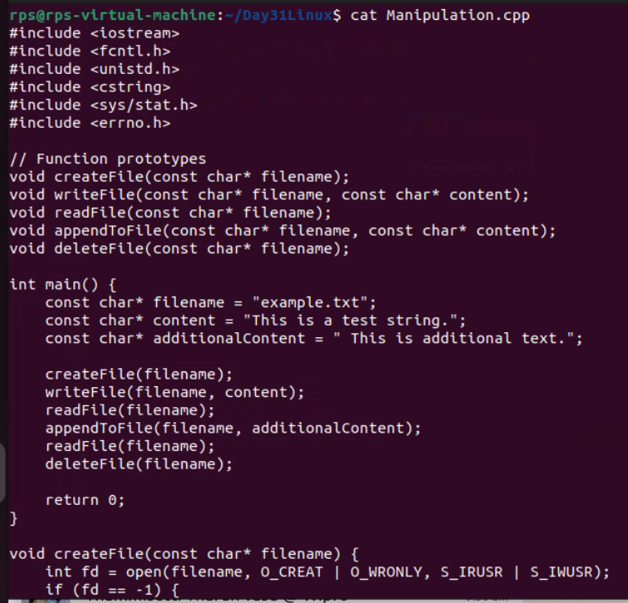

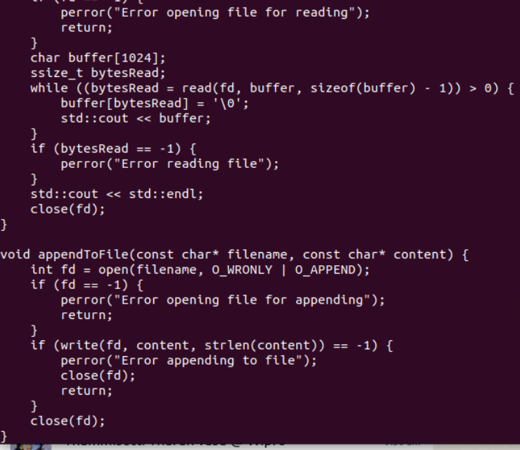

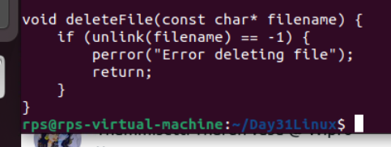

**OUTPUT:**

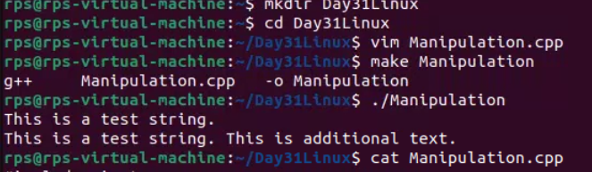

**TASK 2:**

**Client to Server**

**CLIENT**

**CODE:**

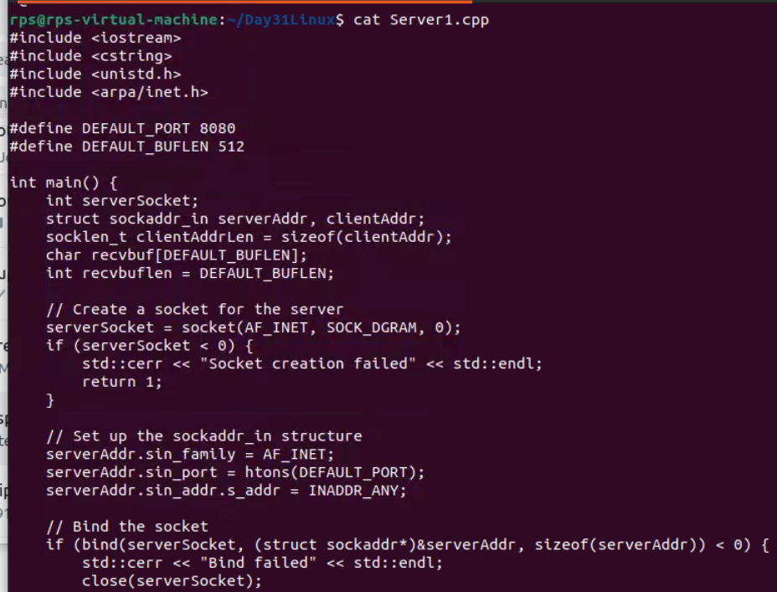

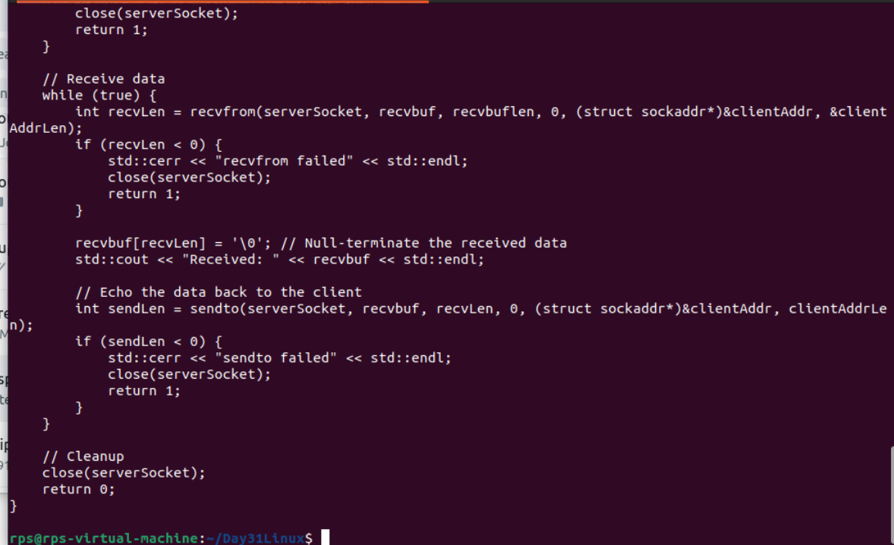

**OUTPUT:**

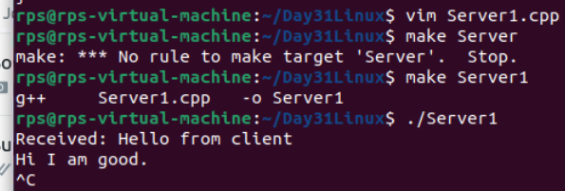

**CLIENT**

**CODE:  
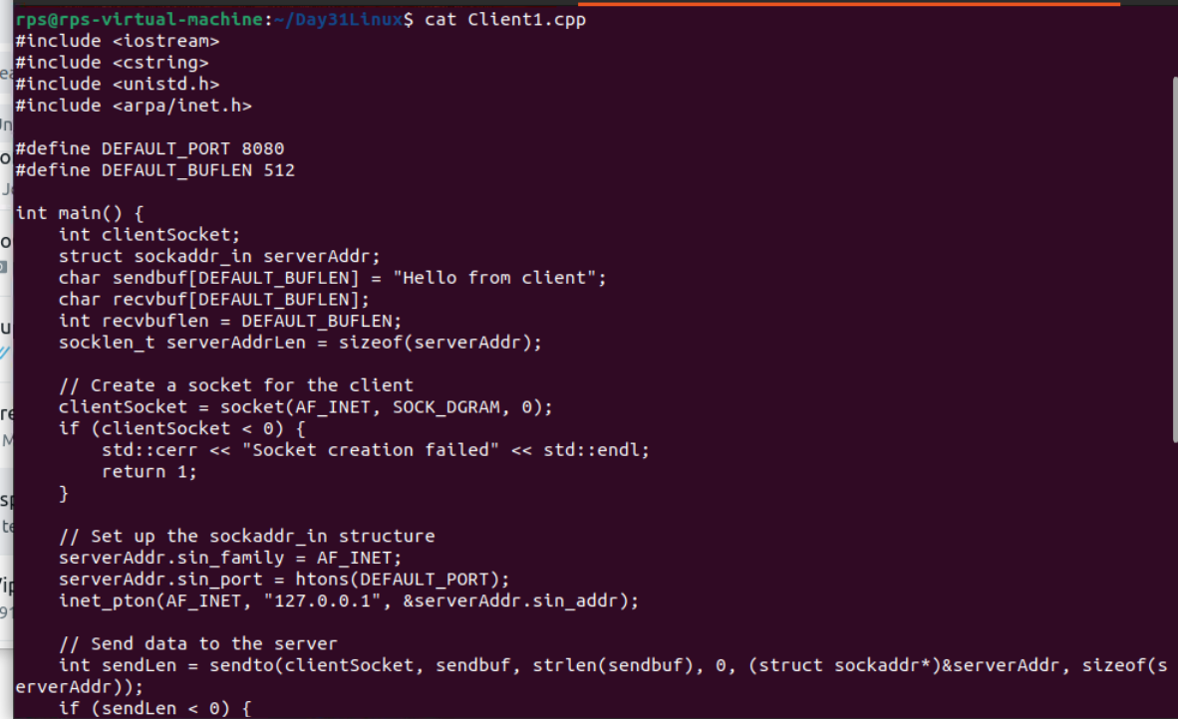**

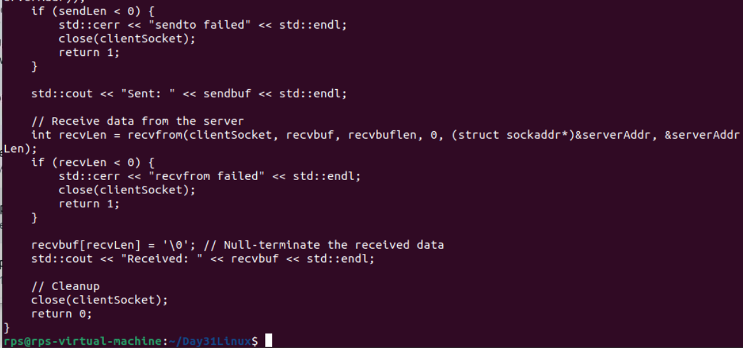

**OUTPUT:**

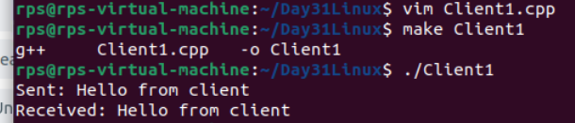

**TASK 2:**

**Create a file and send it from client to server**

**SERVER:**

**CODE:**

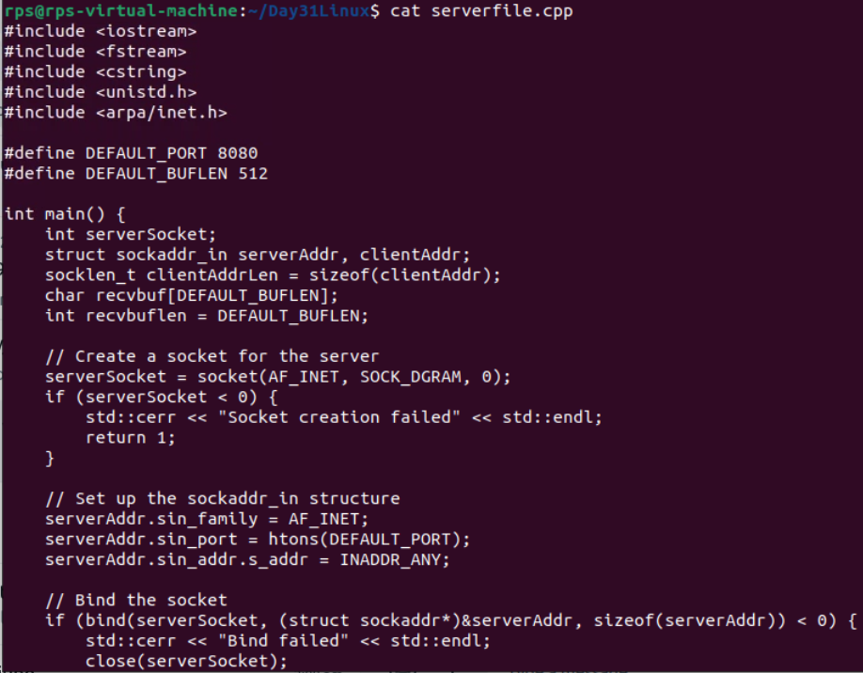

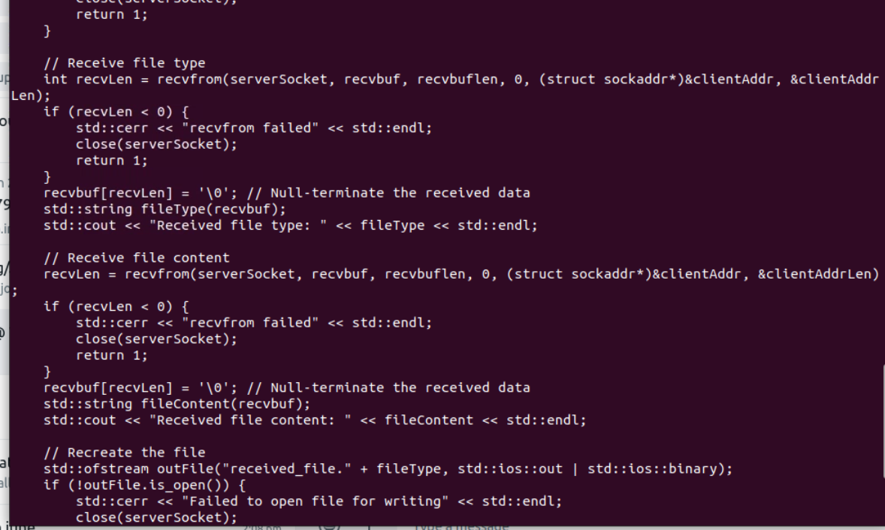

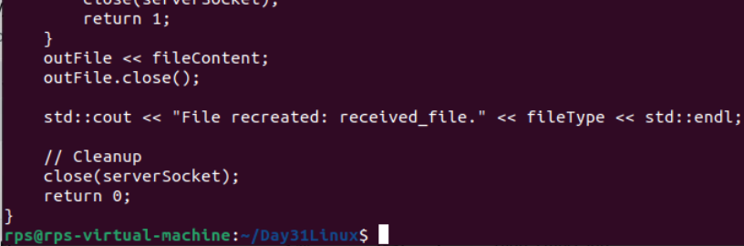

**OUTpUT:**

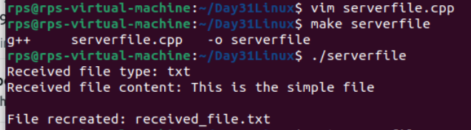

**CLIENT:**

**CODE:**

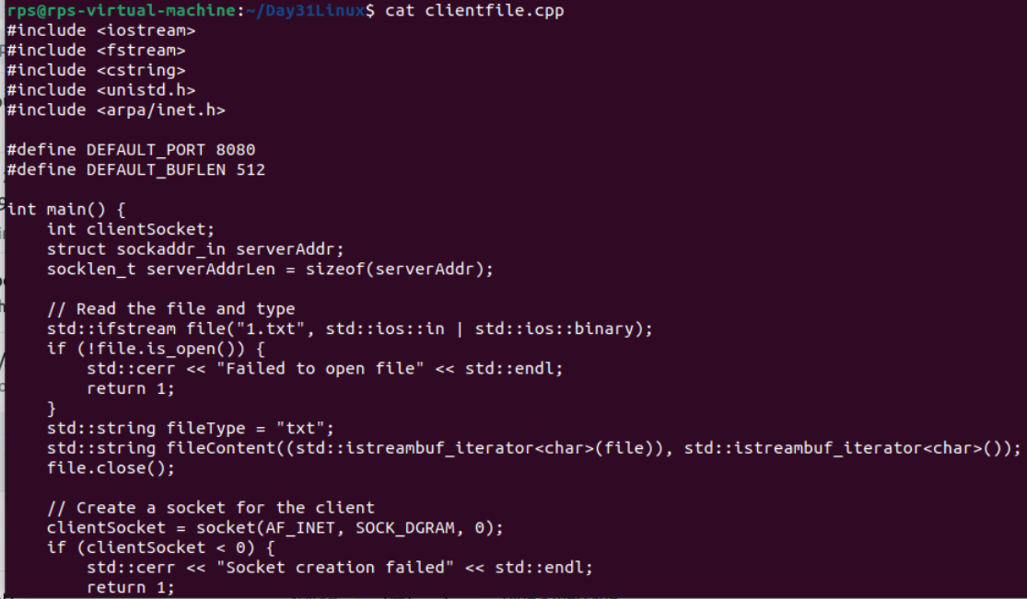

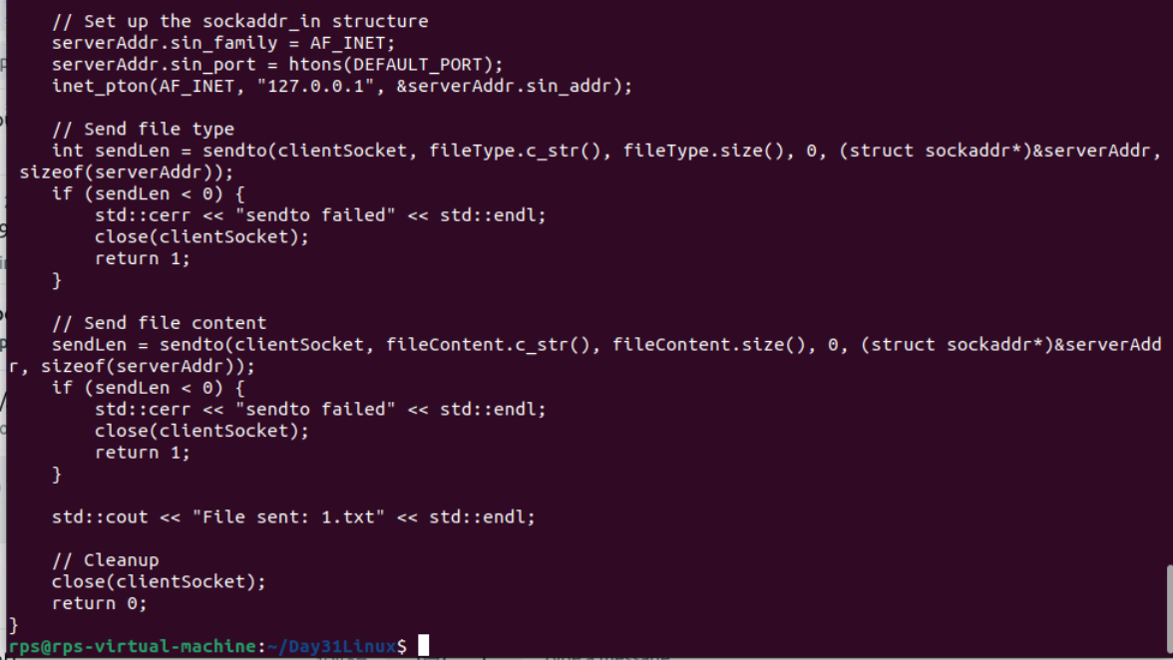

**OUTPUT:**

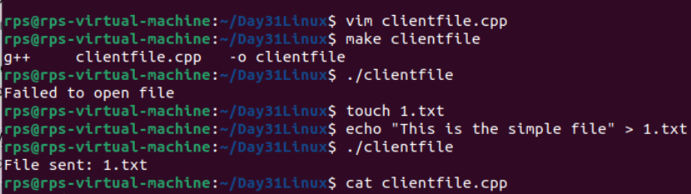

**TASK 3:**

**UDP Server Implementation:**

**Create a UDP socket.**

**Bind the socket to a specified port.**

**Implement a loop to continuously listen for incoming messages.**

**Upon receiving a message:**

**Print the received message along with the client’s address and port.**

**Send an acknowledgment message ("Message received") back to the client.**

**Ensure proper error handling and resource cleanup.**